**How To Enable ICMP Protocol In Linux And Windows**

**For Linux**

According to below screen shot we trying to ping azure public IP, but we are not able to ping it.

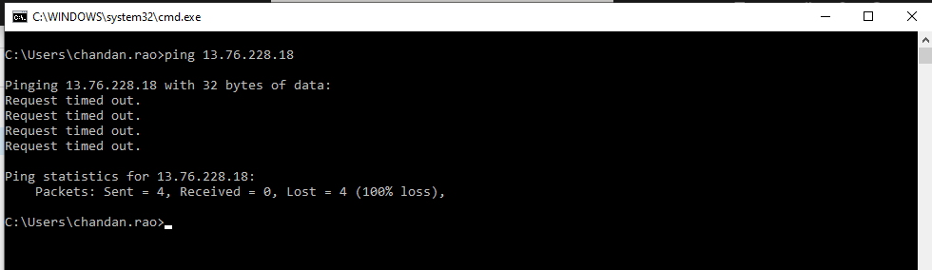

**For enabling it we need to follow below steps**

Step 1: - For allowing ping we need to add ICMP protocol in NSG for that follow the below screen shot.

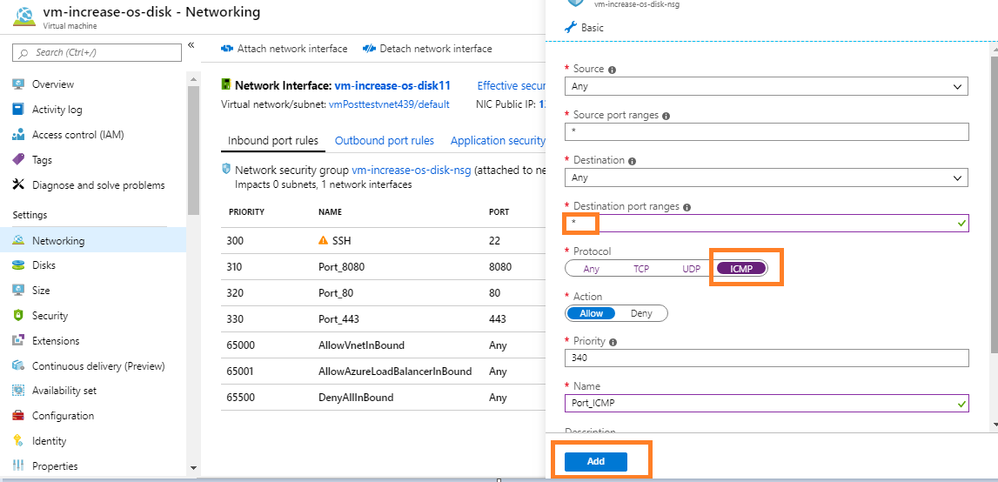

After adding ICMP in NSG we can ping

**Note:** - For Linux we don’t need to do modification inside vm.

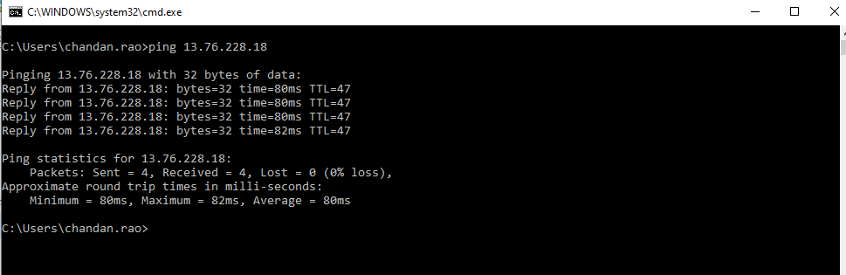

**For Windows**

**Step 1**

Add the ICMP port in NSG

For adding NSG we need to click on Network Blade then “Add Inbound Port Rule”

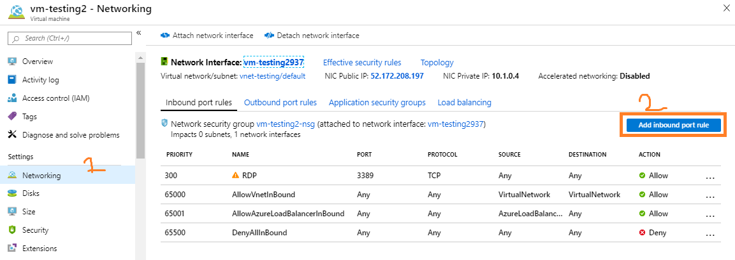

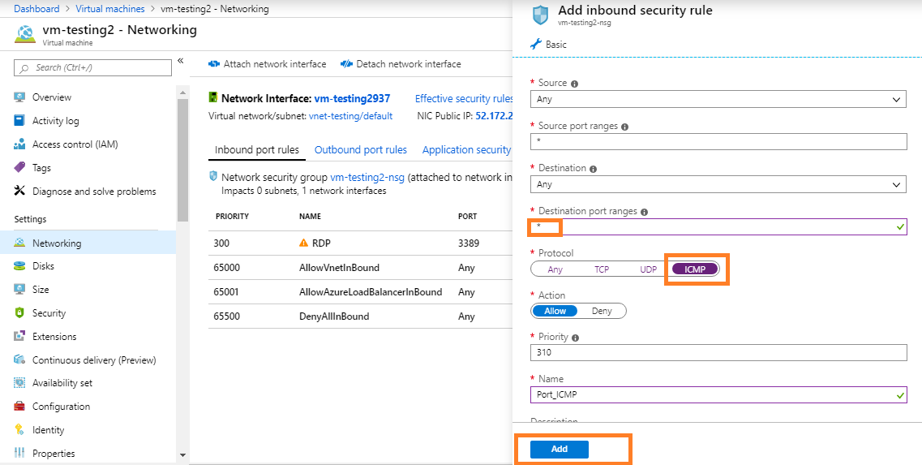

Step 2 After adding ICMP protocol in NSG Next step we need to allow ICMP protocol in windows server.

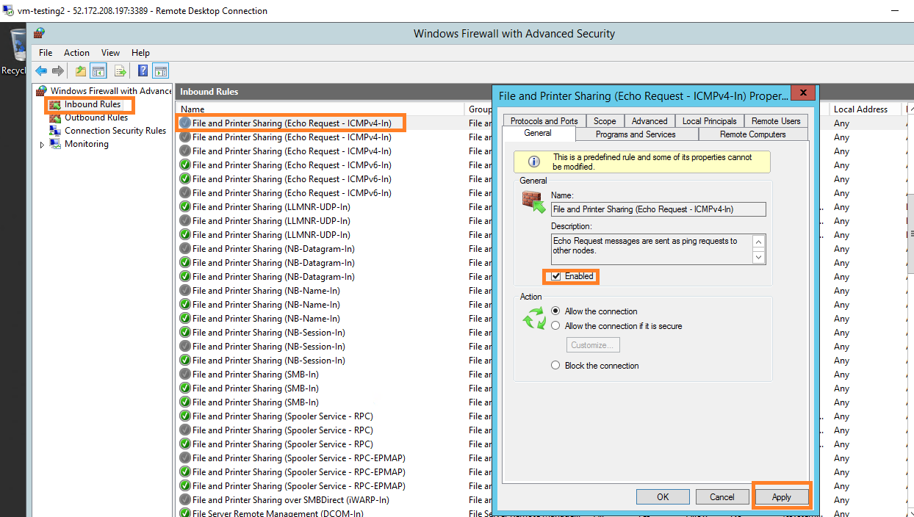

After enabled the ICMP in windows server we can ping it.

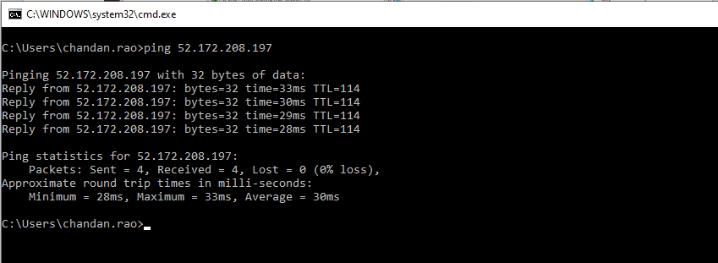

**Reference :-** <https://www.thomasmaurer.ch/2019/09/how-to-enable-ping-icmp-echo-on-an-azure-vm/>